**EXPERIMENT NO:-6**

**AIM:**

To familiarize with join or cartesian product

**PROCEDURE:**

1. Give name of customers having living city BOMBAY and branch city NAGPUR

SELECT D1.CNAME,D1.BNAME,C1.CNAME,C1.CITY,B1.CITY,B1.BNAME FROM DEPOSITE D1,CUSTOMER C1,BRANCH B1 WHERE C1.CITY = 'BOMBAY' AND B1.CITY='NAGPUR' AND D1.CNAME = C1.CNAME AND D1.BNAME = B1.BNAME;

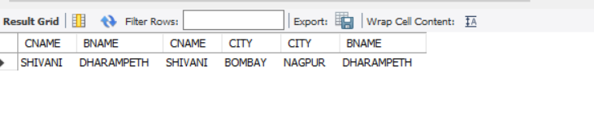

1. Give names of customers having the same living city as their branch city

SELECT DISTINCT(CUSTOMER.CNAME), BRANCH.CITY FROM BRANCH,CUSTOMER WHERE BRANCH.CITY = CUSTOMER.CITY;

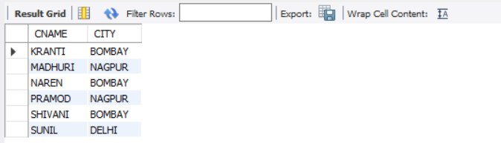

1. Give names of customers who are borrowers as well as depositors and having city

NAGPUR.

SELECT C1.CNAME FROM CUSTOMER C1,DEPOSITE D1,BORROW B1 WHERE C1.CITY='NAGPUR' AND C1.CNAME=D1.CNAME AND D1.CNAME = B1.CNAME;

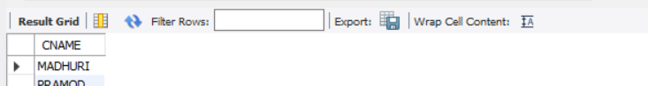

4. Give names of borrowers having deposit amount greater than 1000 and loan amount

greater than 2000.

SELECT BR1.CNAME, BR1.AMOUNT, D1.CNAME, D1.AMOUNT FROM BORROW BR1,DEPOSITE D1 WHERE D1.CNAME = BR1.CNAME AND D1.AMOUNT > 1000 AND BR1.AMOUNT > 2000;

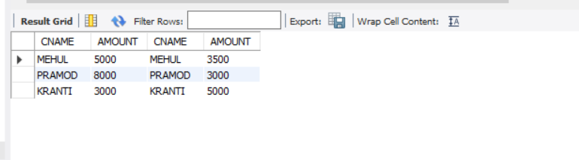

1. Give names of depositors having the same branch as the branch of Sunil

SELECT D1.CNAME FROM DEPOSITE D1 WHERE D1.BNAME IN (SELECT D2.BNAME FROM DEPOSITE D2 WHERE D2.CNAME = 'SUNIL');

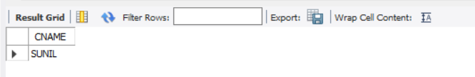

1. Give names of borrowers having loan amount greater than the loan amount of Pramod

SELECT BR1.CNAME, BR1.AMOUNT FROM BORROW BR1 WHERE BR1.AMOUNT > ALL(SELECT BR2.AMOUNT FROM BORROW BR2 WHERE BR2.CNAME = 'PRAMOD');

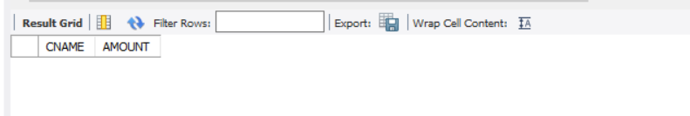

1. Give the name of the customer living in the city where branch of depositor Sunil is

located.

SELECT C.CNAME FROM CUSTOMER C WHERE C.CITY IN (SELECT B.CITY FROM BRANCH B WHERE B.BNAME IN (SELECT D.BNAME FROM DEPOSITE D WHERE D.CNAME='SUNIL'));

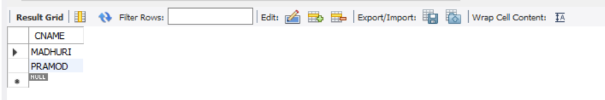

1. Give branch city and living city of Pramod

SELECT B1.CITY , C1.CITY FROM BRANCH B1,CUSTOMER C1, DEPOSITE D1 WHERE C1.CNAME = 'PRAMOD' AND C1.CNAME = D1.CNAME AND D1.BNAME = B1.BNAME;

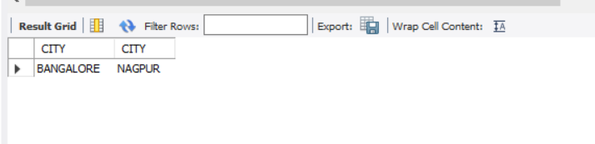

1. Give branch city of Sunil and branch city of Anil

SELECT B1.CITY FROM DEPOSITE D1, BRANCH B1 WHERE D1.BNAME = B1.BNAME AND D1.CNAME IN ('SUNIL','ANIL');

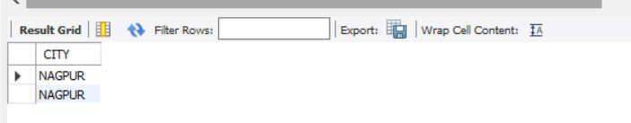

1. Give the living city of Anil and the living city of Sunil

SELECT C1.CNAME, C1.CITY FROM CUSTOMER C1 WHERE C1.CNAME = 'ANIL' OR C1.CNAME = 'SUNIL';

